## User Guide

1. Once the application is started (see 10.2. Installation Guide), users will see the following landing page in their browser.

Figure 1-1: Figure showing Landing Page of Spot My Fish

1. Start using Spot My Fish application by clicking on the upload button to select an image.

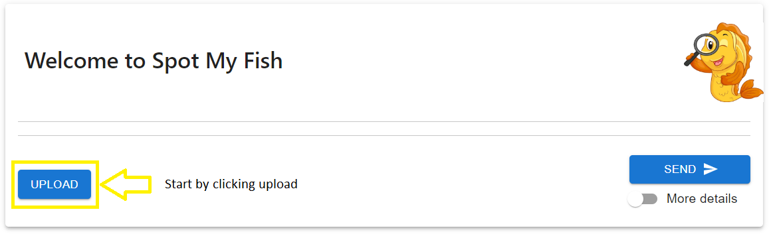

Figure 1-2: Figure focusing on the UPLOAD button of Spot My Fish

1. A file explorer popup window will appear, and user can navigate to their saved image that they desire to use for classification.

Figure 1-3: Figure showing explorer popup after pressing UPLOAD

1. Once an image is selected via clicking “Open” in the explorer, the image will appear in the landing page like below:

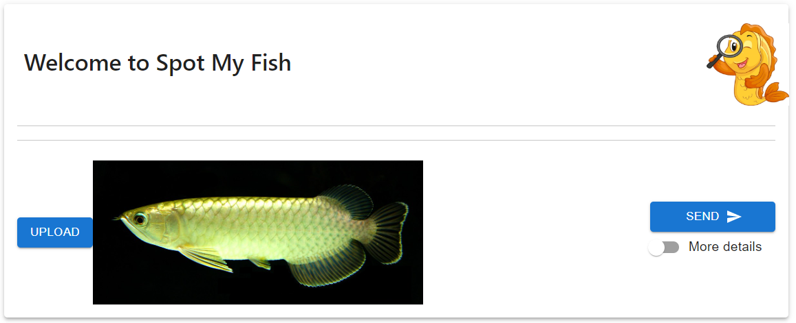

Figure 1-4: Figure showing landing page after user selects an image using UPLOAD

1. Click the “Send” button to start the classification process.

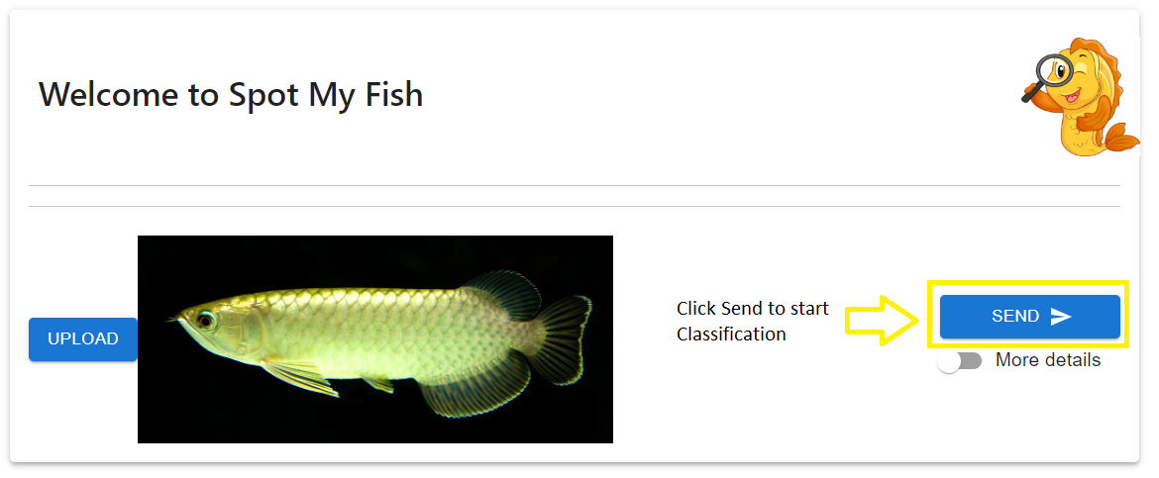

Figure 1-5: Figure focusing on the SEND button of Spot My Fish

1. User will need to wait patiently for about 2 to 3 seconds, and the classification result will be returned as follows:

Figure 1-6: Figure focusing on the classification results after clicking the SEND button

1. For academics/technical users, they can also check the “More details” radio button to see more results from the hybrid model the application uses.

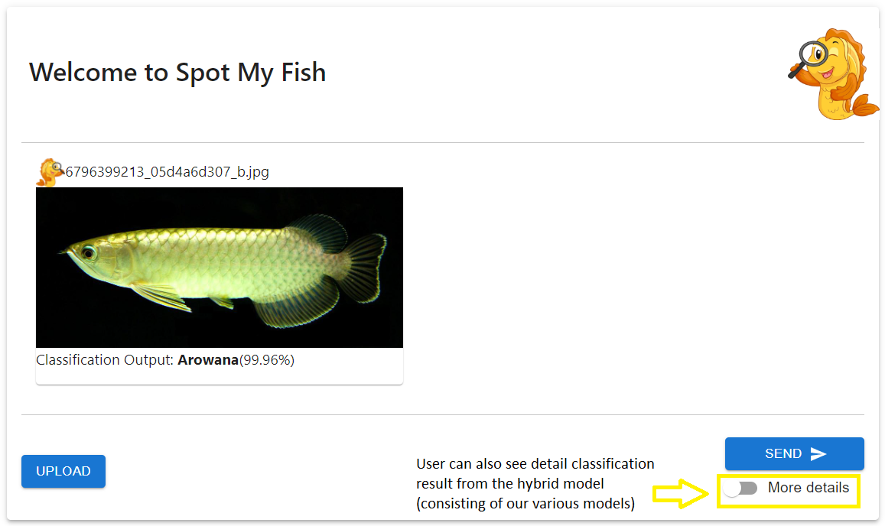

Figure 1-7: Figure focusing on the More details radio button of Spot My Fish

Figure 1-8: Figure showing the various model results used by the hybrid model if user activate the More details radio button of Spot My Fish